Climate resilience for Hong Kong
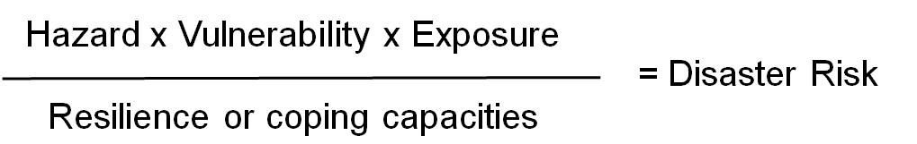
The signs of climate change are apparent in Hong Kong. We are encountering longer and hotter summers and wetter winters. Temperature fluctuations are commonplace from cold to warm spells and back again as shown earlier this year, and we are likely to have more frequent storms. Hong Kong’s weather changes are emblematic of the challenges cities are facing worldwide. Whilst Hong Kong’s engineered infrastructure is designed to cope with weather extremes thus preserving the city from the worse ravages from climate change that other less developed cities face, nonetheless we must prepare ourselves for systemic problems that will arise in the future. In other words, Hong Kong is a city dependent on a series of interlocking systems: which include energy, water, communications and transportation. Should one system break down, then the entire city grinds to a halt. For instance if the power goes down, then computers and servers go down. Similarly if water services fail then public health issues arise. The integrity of these systems to withstand climate shock is known as resilience. Resilience is related to risk as follows:

A hazard, such as a typhoon or landslide by itself does not lead to disaster unless it affects an exposed community. The level of exposure is a function of how vulnerable that community is, for instance one that lives in a low lying plain is more vulnerable to flood impacts than one which lives on safer high terrain. Increasing the resilience of a city hence lowers the risk of disaster. But although this seems like common sense, sadly many cities end up spending more on disaster recovery rather than prevention. A report by Global Humanitarian Assistance, an NGO, estimates that only US$1 out of every US$100 spent on humanitarian aid is spent on disaster risk reduction.
How can Hong Kong avoid this dilemma? Currently, there are many engineering provisions such as master drainage plans and building and construction codes that ensure the functionality and integrity of our disaster measures. However, there are vulnerable areas such as power lines and railways that are susceptible to climate shock. We have not done enough in these areas. In addition, safe water is another liability as we are dependent on supplies from the mainland and we have not done enough in the way of conserving our own resources. To improve resilience, we should undertake a risk assessment to determine which areas are at risk. The obvious ones have already been highlighted but what about the stresses as opposed to the shocks? Water and energy stresses can be just as damaging to Hong Kong as summers get hotter and water becomes scarcer either for consumption or for critical processes like cooling water for power stations.
Hong Kong’s engineers are noted for their innovation. The first place to start the risk assessment is to consider all climate-related issues followed by a brainstorming of mitigation measures as well as developing the right institutional capacity. The Hyogo Framework is at the heart of building resilience in cities and communities, and was recently updated at the World Disaster Risk Reduction that took place in Sendai last March. Using this, we can learn from others and become a wiser as well as a resilient city.
-------------------------------------------------------
This article is contributed by Dr Thomas S.K. Tang, the DIRECTOR, CORP SUSTAINABILITY, ASIA, AECOM, with the coordination of the Environmental Division of HKIE.

